
NAME: MUDASSAR AHMAD

ROLL: SU92-BSDSM-S25-005

SUBJECT:AI(LAB)

SUBMITTED TO: SIR RASIKH ALI

Artificial intelligence lab week 10

Topic:
Data Loading and Exploring

Contents
Introduction 2
OBJECTIVE 3
Dataset Used 3
ALGORITHM / STEPS 3
CODE 3
OUTPUT 4
Data Read and Load 4
Checking for null values 5
Data info and describe check 5
CONCLUSION 6

Introduction
Pandas is a powerful Python library which is used for the data analysis and manipulation. It can provide data structures like Data Frames which can help us in handling structured data very easily.
Data loading is the process of importing data from the files such as CSV or JSON into an program. Data exploration involves the understanding of the dataset by checking its structure, size, missing values, and data types.
These steps are very important before applying any machine learning or analysis techniques.

OBJECTIVE
To learn how to load the dataset and perform the basic data exploration using the Pandas library in the Python.

Dataset Used
Medical Cost Personal Dataset from Kaggle (https://www.kaggle.com/datasets/mirichoi0218/insurance).

ALGORITHM / STEPS
- Import pandas library
- Load dataset using read_csv()
- Display top 5 rows
- Display bottom 5 rows
- Check number of rows and columns
- Check missing values
- Fill missing values
- Display data types of columns

CODE
# -*- coding: utf-8 -*-
"""AI(LAB)-WEEK-10-BSDS-005.ipynb

Automatically generated by Colab.

Original file is located at
https://colab.research.google.com/drive/1KTJ9vy28DokfAxzjm_ZczuxvrNPq5uOG
"""

import pandas as pd
import numpy as np
df=pd.read_csv('insurance.csv')
print(df.head(5))
print()
print()
print(df.tail(5))

print("ROWS",df.shape[0])
print("COLUNMS",df.shape[1])

print(df.isnull().sum())
print(df.dtypes)

print(df.info())
print()
print(df.describe())

OUTPUT
I have attached the screenshots below for more better understanding.

Data Read and Load
This screen shot shows I loaded the data of insurance.csv by creating a data frame using the python library pandas
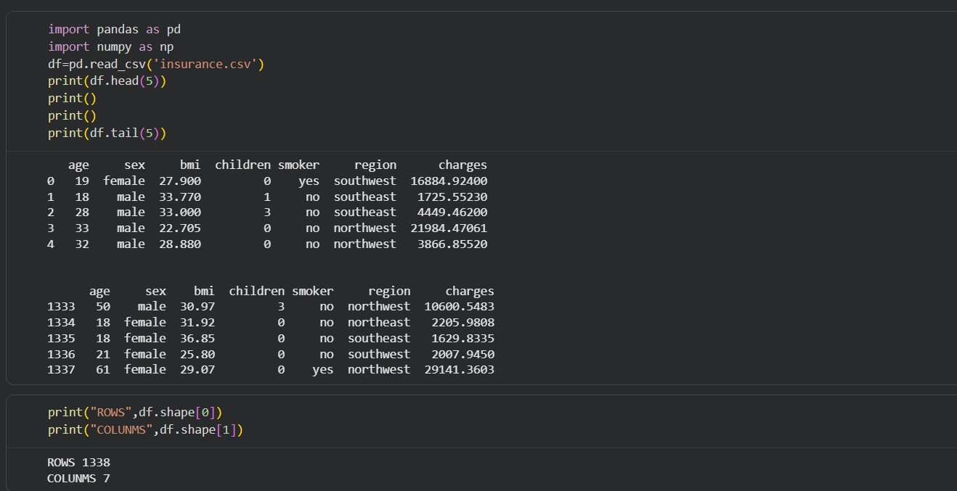

Checking for null values
- I did not find any null values in my data so i skipped the step to fillna to fill null or missing values
- It also checks the data types
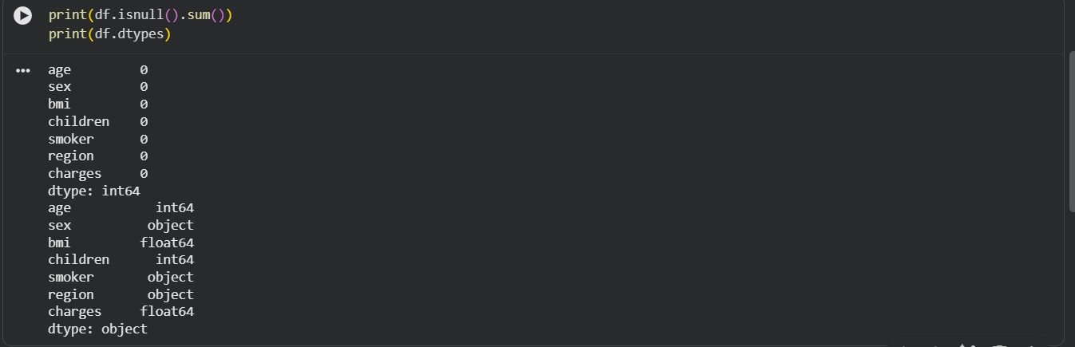

Data info and describe check
- info() gives a summary of the dataset structure.
- describe() gives statistical summary of numerical columns.
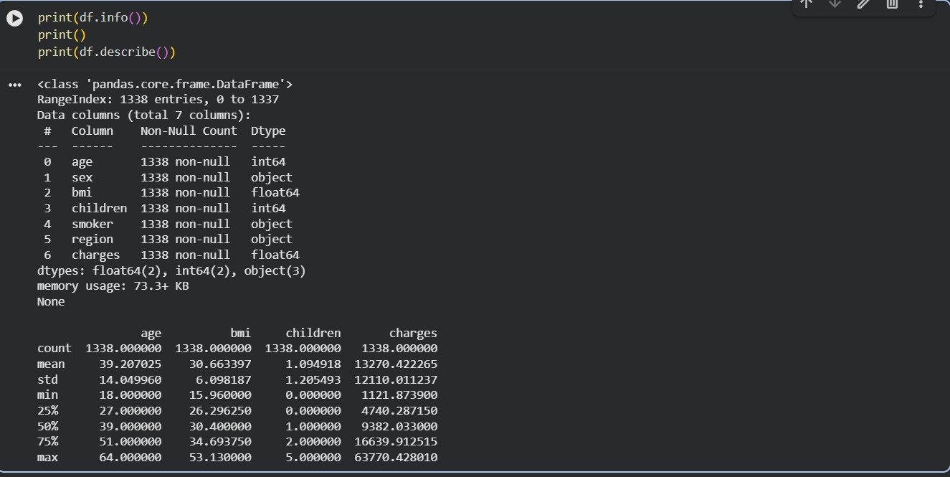

CONCLUSION
In this lab, successfully loaded a dataset using Pandas and performed basic data exploration. We checked the structure of the dataset, managed missing values, and analysed data types. These steps are essential for preparing data before applying machine learning algorithms.

